StatsWrap Documentation

Vision

For a fitness enthusiast that likes to know every intimate detail of their workout, StatsWrap is an activity tracker that records and graphs all of one’s fitness data in real time. This allows athletes to tailor their workouts with incredible accuracy. Unlike competitors, StatsWrap focuses on keeping your data secure and presenting high fidelity information in a concise live graph.

Activity Tracker Software FURPS Requirement Model:

**F** – Allows the user(s) to view their activity logs, or reported statistics from the software system. A unique user cannot open multiple sessions. The data being tracked can be reset at any time.

**U** - Software uses a Graphical User Interface to allow users to easily assess with all information provided electronically through a digital screen on the watch. Information on screen is presented clearly with a white background and black text to help colorblind users read their activity logs, etc.

**R** – The software will never fail on its own as long as the watch machine in use has the specified minimum required hardware and software without any lag, hitches, or crashes. Once a user begins using the activity tracker software, their data is stored and calculated within the program. The program can be opened and closed or reset at any given time but will not save any specific user’s data.

**P** – The performance of the activity tracker software can handle many inputs and report several statistics at the same time. Information will be adding to the database of the software dynamically during usage. The software is available to as many watch machines that have the software on them. The maximum throughput is dependent on the speeds of the sensors and processors of the watch machines running the software themselves.

**S** – The usage of java as an object-oriented programming language helps ensure longtime support of our activity tracker software with increasing amounts of devices and maintenance of the code. Developers of the software in the future can add support for different languages and UI screen sizes for when using our software.

Implementation

**System Requirements:**

jre 1.8.0_201

Installation of Java 8

OS compatible with Java

Open-Source Software requirements.

The small watch machine running our activity tracker software need at least Java version 8. Alongside Java 1.8 SE, the watch machines need Scenebuilder and JavaFX installed to run the graphical user interface of our software. An operating system such as Windows 7 or higher, Mac OS, or Linux 13.0 installed on the watch machines with our software is recommended for an easier setup for running the activity tracker software.

Gadgetbridge is an open source software for the Android Operating System that could be used in deployment for our activity tracker software to bypass installing previously mentioned Operating Systems, as well as their hardware requirements.

PostgreSQL is an open source database software that would be used to manage the user input data for the activity tracker system. An essential component for reporting the graphs of the user stats.

Purchased Hardware requirements.

A machine shaped like a watch with a processor inside to run our activity tracker software. The machine running our activity tracker software itself must include a light sensor using LED technology. The machine needs to have a minimum of 126 MB of Disk Space for JRE (Java Runtime Engine); 2 MB for Java Update. Minimum of 128MB of RAM. Minimum specified processor to run our software is at least an Intel Pentium 2 266 MHz processor or a comparable processor in performance. A micro-USB cable is required to setup our software initially onto the machine watches before usage.

Legal Issues

**Activity Tracker Inaccuracies:**

An error of the data being read improperly from the light emitting diodes (LEDs). The results presented on the activity tracker software is incorrect and may serve to be unreliable without the customer knowing. Customers with heart diseases who need to guarantee a specific range of their own heart rate may face demise.

**Inconvenience of Usage:**

Users of an activity tracker must not strain their eyes looking for a particular set of information. Users performing dangerous activities such as driving while using the activity tracker is highly not recommended. However, users may be receiving notifications during participation of dangerous activates and could hurt themselves or others. Software should be display information comprehensively and attempt to not be very invasive too frequently.

Glossary

**Account Information** - The information stored within the activity tracker software which may include activity logs, alarms, and heartrate.

**Activity Log(s) -** The logged data of all sensors within the Activity tracker

**Alarm(s) –** time based notifications

**Application –** a piece of software designed and written to fulfill a specific task

**Calorie –** the amount of energy required to raise 1 gram of water 1 degree Celsius

**Display -** the area of the watch capable of displaying data

**Device API -** a set of functions and procedures allowing the creation of applications that access the features or data of an operating system, application, or other service.

**Component –** an aspect of a larger entity

**Database –** a structured set of data held in a computer, especially one that is accessible in various ways

**Settings –** options to change how the system looks, works, etc.

**Heartrate –** number of heart beats per minute (bpm)

**LED –** abbreviation for Light emitting diode.

**Gait –** an individual’s manner of walking

**Plateau –** a period of stagnation in a workout regimen, diminished returns on workouts

Use Cases

***Use Case (UC1):***

View Graphs

**Scope:**

The current User using the activity tracker software

**Level:**

To allow a user to view their graphs in real time

**Actor:**

User, System

**Stakeholders:**

User: Wants to be able to view their graphs accordingly and properly.

**Preconditions:**

Data exists for system to display graphs

**Postconditions:**

System displays graphs for user, then returns to default screen when user exits.

**Main Success Scenario:**

(UC1main):

1. User chooses view graphs

2. System collects necessary data

3.  System generates live graphs

4. User can easily select which graph to view

5. User can swap graphs with a single button press

6. System updates charts as new data is retrieved

**Extensions:**

(UC1a): UI does not allow for easy graph selection during exercise

(UC1b): System generates graphs with incorrect data

(UC1c): Graphs are not easily readable (unlabeled axes, bad scale, etc.)

(UC1d): Graphs do not update with live data

**Special Requirements:**

User must have logged some data in order to view graphs

**Variations in Tech and Data:**

Users all have unique data, tech is consistent

**Frequency of Occurrence:\**

Many times a day

**Miscellaneous:**

N/A

***Use Case (UC2):***

Set New Activity Goal

**Scope:**

The current User using the activity tracker software

**Level:**

User chooses a new goal value and timeline on which to achieve said goal

**Actor:**

User, System

**Stakeholders:**

User: Wants to be able to set a new activity goal

**Preconditions:**

User must know the goal and timeline to enter the data

**Postconditions:**

System must graph goal line based on input values

**Main Success Scenario:**

(UC2main):

1. User selects “Set New Goal”
2. System prompts user to choose which category to set a new goal in
3. User selects a category (Sleep, steps, heart rate, etc.)
4. System asks user what the new goal should be
5. System asks user when the user wants to achieve this goal by
6. User selects a timeline on which to complete the goal
7. System records new goal and timeline
8. System displays live chart with goal line graphed

**Extensions:**

(UC2a): System does not allow for goal setting

(UC2b): System fails to capture necessary data to graph goal line

(UC2c): Graph is cluttered, incorrect, or unreadable

(UC2d): Goal line is not distinguished from actual values

(UC2e): System does not update live charts with goal line

**Special Requirements:**

User must have a goal in mind and timeline

**Variations in Tech and Data:**

All data is unique to users, tech is consistent

**Frequency of Occurrence:**

Varies, infrequently to multiple times per day

**Miscellaneous:**

N/A

***Use Case (UC3):***

Stop recording data

**Scope:**

The current User using the activity tracker software

**Level:**

User selects stop recording from the interface

**Actor:**

User, System

**Stakeholders:**

User: Wants to be able to stop recording data

**Preconditions:**

User must be already recording data for the stop recording data button to be present

**Postconditions:**

System must not log any data from sensors

**Main Success Scenario:**

(UC3main):

1. User selects “Stop Recording Data”
2. The system alerts the array sensor to stop recording data
3. The system alerts the user that no data is being recorded
4. An icon that represents the Stop Recording Data state is persistent on the interface while the system is not recording data

**Extensions:**

(UC3a): System fails to stop recording data

(UC3b): System fails to notify user that “Stop Recording Data” button press was successful

(UC3c): Icon notifying user of not recording data is not persistent on screen

**Special Requirements:**

User must already be recording data in order for “Stop Recording Data” button to be present

**Variations in Tech and Data:**

All data is unique to users, tech is consistent

**Frequency of Occurrence:**

Varies, infrequently to multiple times per day

**Miscellaneous:**

N/A

***Use Case (UC4):***

Log a new session

**Scope:**

The current User using the activity tracker software

**Level:**

User selects “New Session” from main menu

**Actor:**

User, System

**Stakeholders:**

User: Wants to be able to record new activity session

**Preconditions:**

User must have set up the activity tracker by inputting their basic data (height, weight, resting heart rate)

**Postconditions:**

System must have initialized a new session

**Main Success Scenario:**

(UC4main):

1. User selects “New Session” from main menu
2. System prompts user for name of session
3. System prompts user for which sensors to record data from
4. System prompts user with “Begin Session” and “Cancel” options
5. User selects “Begin Session” and the session is initialized

**Extensions:**

(UC4a): System fails register button press

(UC4b): System fails to prompt user with name of session and data to record

(UC4c): System adds data to existing session or does not record data in new session

**Special Requirements:**

User must have set up basic information (height, weight, age, resting heart rate)

**Variations in Tech and Data:**

All data is unique to users, tech is consistent

**Frequency of Occurrence:**

Varies, infrequently to multiple times per day

**Miscellaneous:**

N/A

***Use Case (UC5):***

View data

**Scope:**

The current User using the activity tracker software

**Level:**

User selects “View Data” from main menu

**Actor:**

User, System

**Stakeholders:**

User: Wants to be able to view logged data

**Preconditions:**

User must have some data logged in the System

**Postconditions:**

System must not have changed any of the data

**Main Success Scenario:**

(UC5main):

User selects “View Data” from main menu

System prompts User for which category they would like to view

User selects a category

System displays data from specified category

**Extensions:**

(UC5a): System fails to register button press

(UC5b): System fails to prompt user with category options

(UC5c): System fails to display or displays incorrect data

**Special Requirements:**

User must have some data logged in System

**Variations in Tech and Data:**

All data is unique to users, tech is consistent

**Frequency of Occurrence:**

Varies, infrequently to multiple times per day

**Miscellaneous:**

N/A

***Use Case (UC6):***

Input data

**Scope:**

The current User using the activity tracker software

**Level:**

User selects “Input Data” from main menu

**Actor:**

User, System

**Stakeholders:**

User: Wants to be able to input new data

**Preconditions:**

User must have set up basic information (age, weight, resting heart rate)

**Postconditions:**

System must have recorded new data input

**Main Success Scenario:**

(UC5main):

1. User selects “Input Data” from main menu
2. System prompts User for name of new data to be entered
3. User selects a name
4. User inputs data to be logged

**Extensions:**

(UC5a): System does not allow new data to be input

(UC5b): System fails to store data input by User

(UC5c): System does not allow access to data after entry

**Special Requirements:**

User must have set up basic information (height, weight, age, resting heart rate)

**Variations in Tech and Data:**

All data is unique to users, tech is consistent

**Frequency of Occurrence:**

Varies, infrequently to multiple times per day

**Miscellaneous:**

N/A

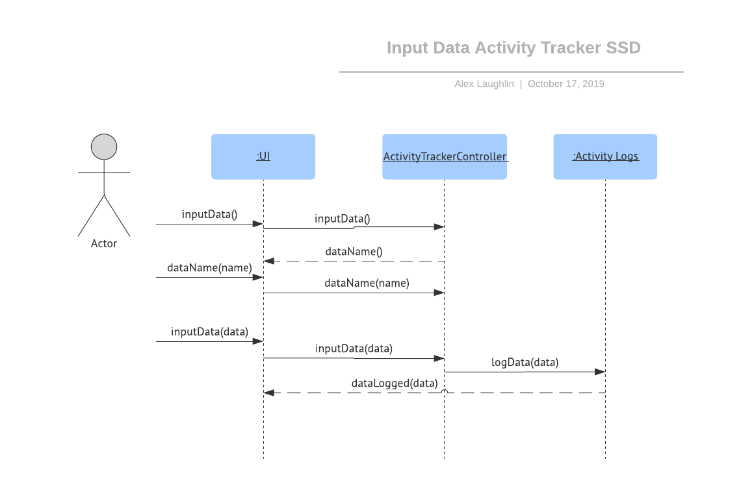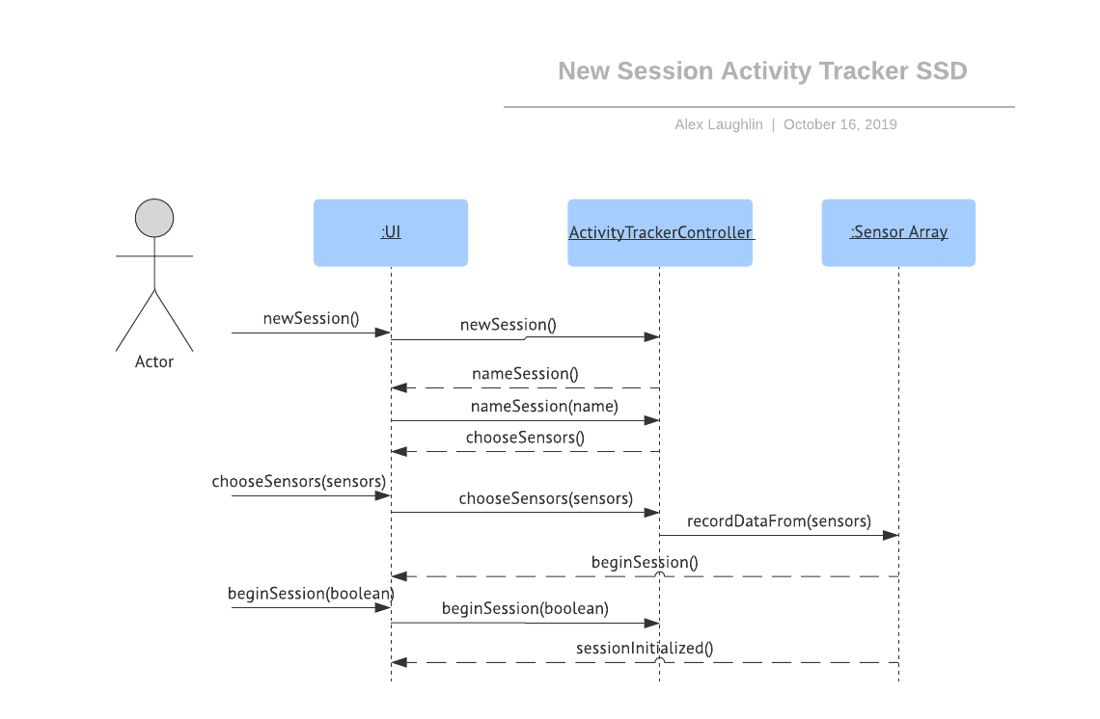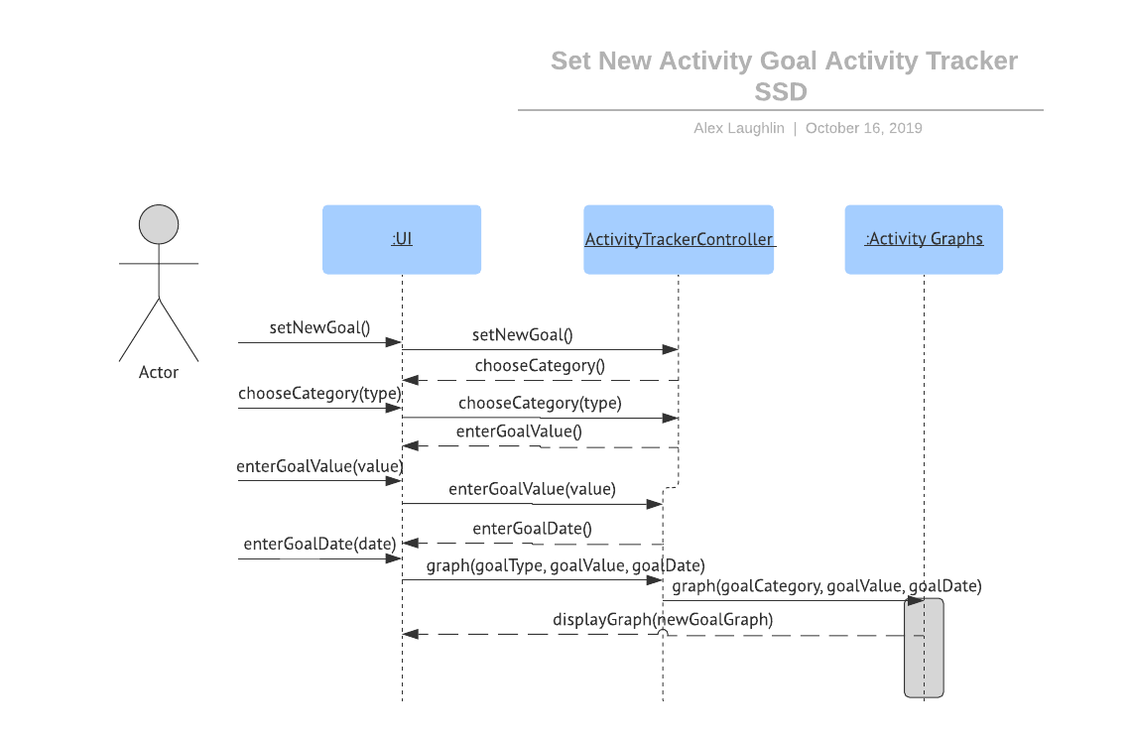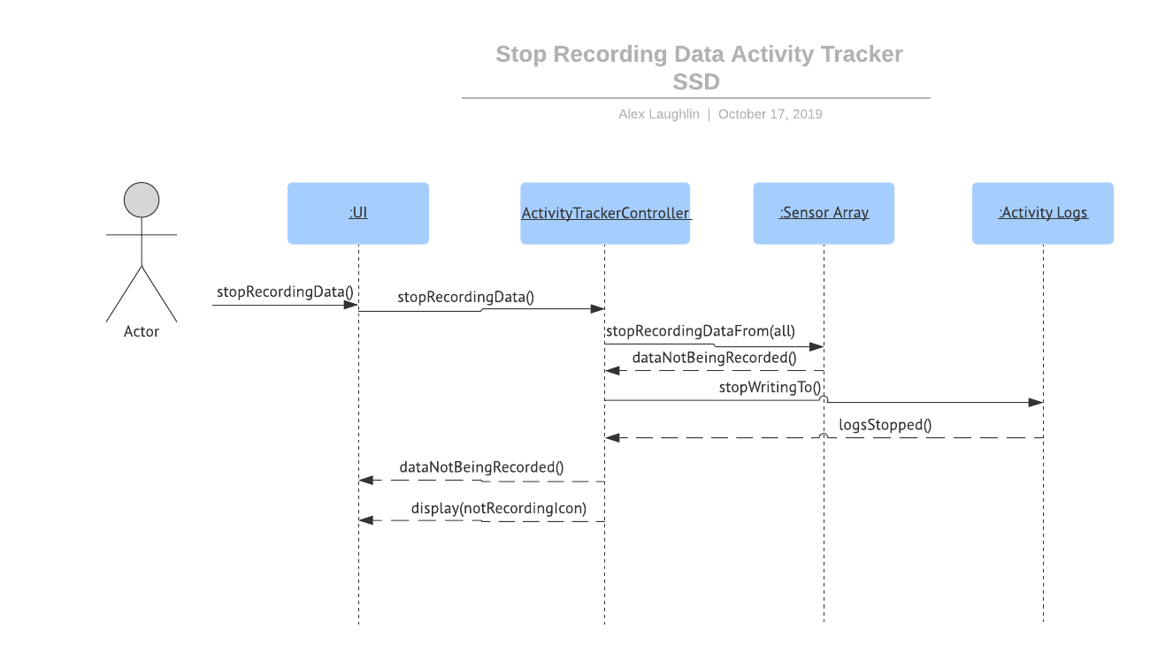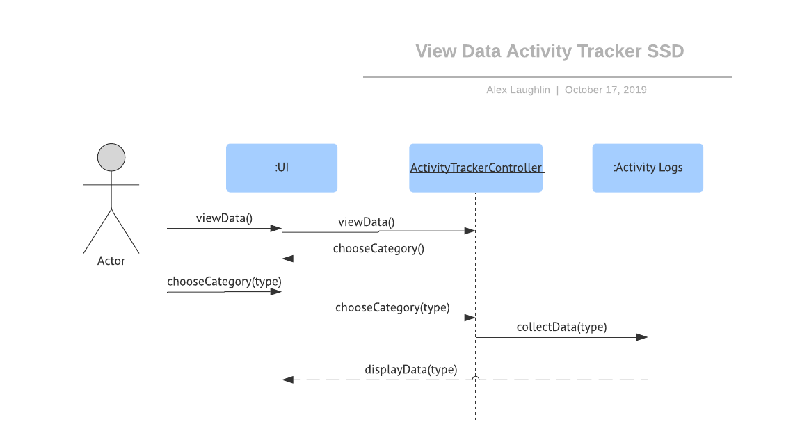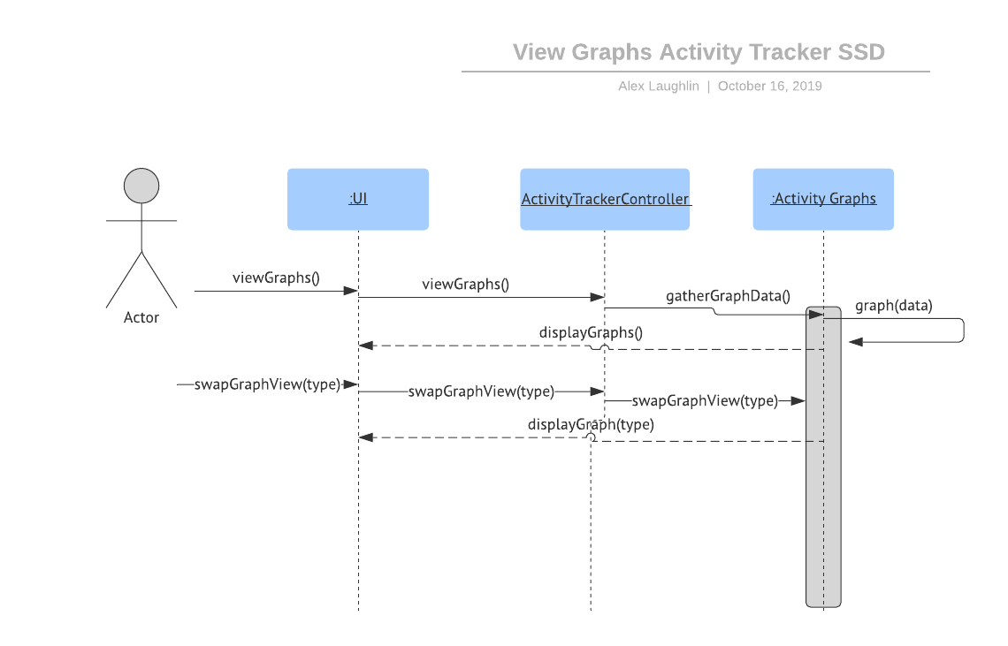

**Contract CO1: viewGraphs**

**Operation:**

viewGraphs()

**Cross References:**

Use Cases: View Graphs

**Preconditions:**

User must have some data for System to graph

**Postconditions:**

**-**Several Graph instances were created *(instance creation)*

-The Graphs are representations of the Data *(association formed)*

-The Graphs are displayed on the User Interface

**Contract CO2: Set Activity Goal**

**Operation:**

setNewGoal(goalType, goalValue, goalDate)

**Cross References:**

Use Cases: Set New Activity Goal

**Preconditions:**

-None

**Postconditions:**

**-**A Goal instance was created *(instance creation)*

-The System has assigned the Goal instance a type, value, and end date *(association formed)*

-A Graph instance was created (*instance creation)*

-The Graph is a representation of the Goal (*association formed)*

**Contract CO3: Stop Recording Data**

**Operation:**

stopRecordingData()

**Cross References:**

Use Cases: Stop Recording Data

**Preconditions:**

-The sensor array is recording data

**Postconditions:**

**-**The System ceased to record data *(attribute modification)*

-The System has displayed a confirmation that data is not being recorded

**Contract CO4: Log New Session**

**Operation:**

newSession(name, sensors)

**Cross References:**

Use Cases: Log New Session

**Preconditions:**

- User must have set up the activity tracker by inputting their basic data (height, weight, resting heart rate)

**Postconditions:**

**-**The System has initialized a new session instance (*instance creation)*

-The System has associated the name and sensors to record with to the Session instance (*association formed)*

**Contract CO5: View Data**

**Operation:**

viewData(type)

**Cross References:**

Use Cases: View Data

**Preconditions:**

- User must have some data

**Postconditions:**

**-**The System displayed the data from the Activity Logs (*association formed)*

-The System did not modify the data

**Contract CO6: Input Data**

**Operation:**

inputData(name, value)

**Cross References:**

Use Cases: Input Data

**Preconditions:**

- None

**Postconditions:**

**-**The System created a new Data instance (*instance creation)*

-The System created a new Graph instance *(instance creation)*

-The System populated the Graph instance with the Data instance (*association formed)*

Sources:

Fung, Brian (2018, August 2). *Is your Fitbit wrong? One woman argued hers was — and almost ended up in a legal no-man’s land.* Retrieved from <https://beta.washingtonpost.com/technology/2018/08/02/is-your-fitbit-wrong-one-woman-argued-it-was-almost-ended-up-legal-no-mans-land/>

Freeyourgadget (2017, November). *Gadgetbridge.* Retrieved from

<https://alternativeto.net/software/gadgetbridge/>

PostgreSQL. “PostgreSQL: The World's Most Advanced Open Source Database.” *PostgreSQL*, The PostgreSQL Global Development Group, 1996, [www.postgresql.org/about/](http://www.postgresql.org/about/).

<https://dev.fitbit.com/build/guides/glossary/>

<https://www.gearbrain.com/fitness-tracker-glossary-terms-1862551889.html>